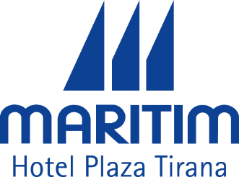 | Hotel Maritim Plaza Tirana Rruga Abdi Toptani 18, 1001  Tirana Albania  Tel: +355 4 22 11 22 1  Fax: +355 4 22 84 01 6
Registration Form
MINEX Europe Forum 2022

Surname: |  | Name:
Phone: |  | E-Mail:
Address: |  | City/Country: | /
Arrival Date: |  | Departure Date:
Arrival Time: | : | Departure Time: | :

Room Category Rates | - Business Room | - Superior Room | - Deluxe Room | - Suite Single Use
Single Use | 115 € / night | 135 € / night | 195 € / night | 290 € / night
Double/Twin Use | 139 € / night | 159 € / night | 219 € / night | 314 € / night
Description
Check in time: 14:00 - Check out time: 12:00
Included: American buffet breakfast, SPA & GYM access, Wi-Fi and Parking and all taxes.

Cancellation Policy
This reservation can be cancelled or modified free of charge until 7 days prior to arrival date.
In case of no show a penalty of 1-st night will be applied.

Credit card no: | - | - | Valid to: | / | CVV
Credit card issuing bank:
Credit card holder name and signature:

Submit Registration to: booking@plazatirana.com

Please complete and return this form by e-mail latest by 1st of July 2022.

All reservation after this date are subject to availability.

Mr. Endion Shmilli Reservation Department
Hotel Maritim Plaza Tirana

